**University School of Automation & Robotics**

Course – Artificial Intelligence & Data Science

Batch – 2023-2027 [B1]

Name – Utsav Maji

Enrollment No. - 02219051923

**Index**

|  |  |  |
| --- | --- | --- |
| S.No. | Programs | Date |
| 1 | Hello World Program |  |
| 2 | Program to add two numbers |  |
| 3 | Program including Conditional Operators |  |
| 4 | Program including Relational Operators |  |
| 5 | Program to check whether a no. is Even or Odd |  |
| 6 | Program to check whether a no. is Prime or not |  |
| 7 | Program to read n no. of values in an array and display in reverse order |  |
| 8 | Program to find sum of all elements in an array |  |
| 9 | Program to copy element of an array to another array |  |
| 10 | Program to count total no. of duplicate elements in an array |  |
| 11 | Program to find the max. and min. elements in an array |  |
| 12 | Program to sort array elements in descending order |  |
| 13 | Program to sort array elements in ascending order |  |
| 14 | Program to insert values in an array |  |
| 15 | Program to delete an array at a desired position |  |
| 16 | Programs to print given patterns |  |

# Aim: Write a Program to Print Hello World

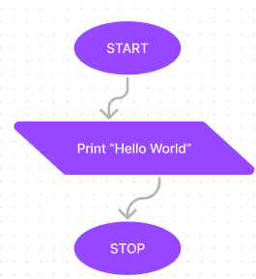

## Algorithm

Step 1 – START

Step 2 - Print Hello World

Step 3 - STOP

## Program

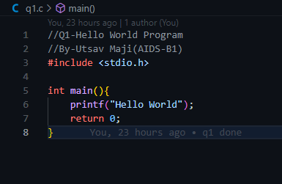

## Output

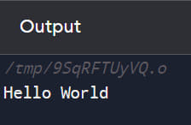

# Aim: Program to add two numbers

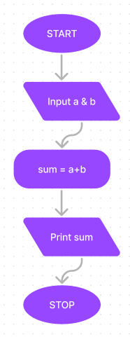

## Algorithm

Step 1 – START

Step 2 – Create 2 Variable of Integer Data-Type, a & b.

Step 3 – Print “Enter First No.”.

Step 4 – Input the First No. , a.

Step 5 – Print “Enter Second No.”.

Step 6 – Input the Second No. , b.

Step 7 – Add variable a & b and store then in another variable named sum.

Step 8 – Print the sum.

Step 9 – STOP.

## Program

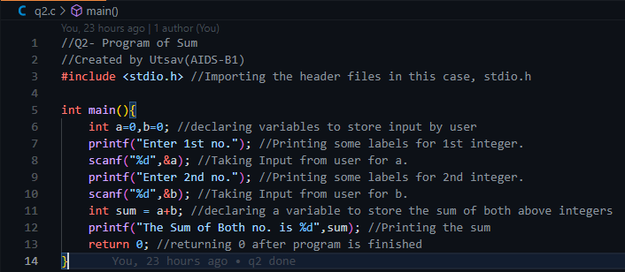

## Output

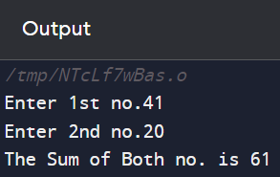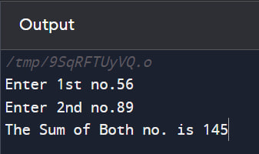

# Aim: Write a Program using Relational Operator

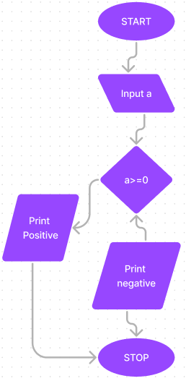

## Algorithm

Step 1 – START

Step 2 – Create a variable a.

Step 3 - Print “Enter a no. ”.

Step 4 – Input a no. in ‘a’.

Step 5 – If ‘a>=0’ is true, print “Entered no. is Positive”

else print “Entered no. is Negative”.

Step 6 – STOP

## Program

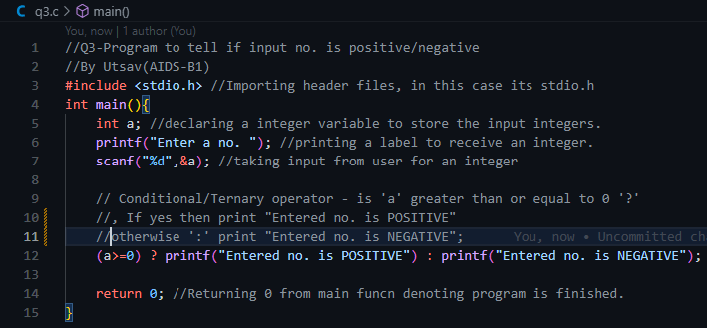

## Output

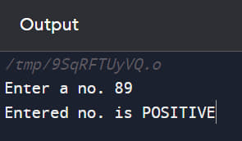

# Aim: Program using Relational Operator

## Algorithm

Step 1 – START

Step 2 – Create two variables a & b.

Step 3 - Print “Enter First No.”.

Step 4 – Input the First No. , a.

Step 5 – Print “Enter Second No.”.

Step 6 – If ‘a>b’ is true, print “1st number is greater than 2nd number”.

Step 7 – else if ‘a=b’ is true , print “Both nos. are equal”.

Step 8 – Else print “2nd number is greater than 1st”.

Step 9 – STOP

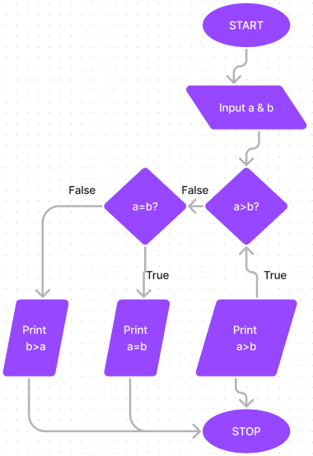

## Program

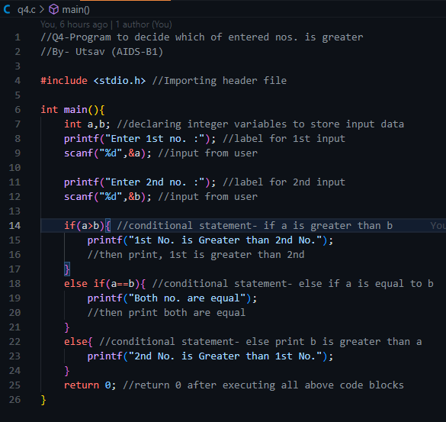

## Output

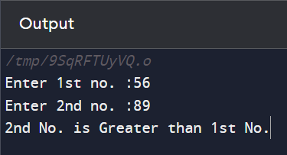

# Aim: Program to check whether a no. is Even or Odd

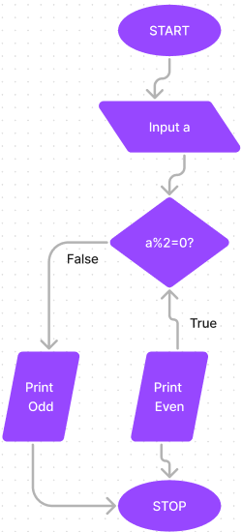

## Algorithm

Step 1 – START

Step 2 – Create a variable ‘a’.

Step 3 – Print “Enter a no.”

Step 4 – Input a no. to “a”.

Step 5 – If remainder of a/2 is zero, print “Entered no. is Even”.

Step 6 – else print “Entered no. is odd”.

Step 7 – STOP

## Program

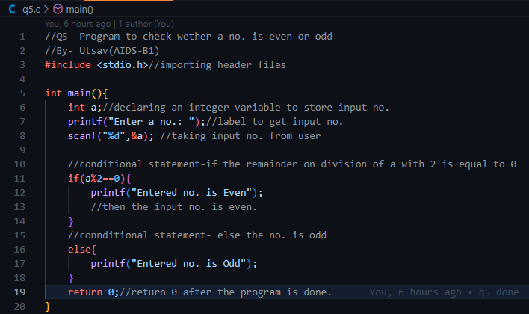

## Output

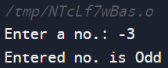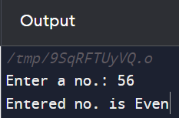

# Aim: Program to check whether a no. is prime or not

## Algorithm

Step 1 – START

Step 2 – Create a variable ‘a’ to store input.

Step 3 – Input a no. for ‘a’.

Step 4 – Create a Bool Variable ‘isPrime’ and set it as false default.

Step 5 – if “a>3” is true, move to further steps.

Step 6 – initialize integer ‘i’ as ‘2’.

Step 7 – if ‘a/I = 0’ is true, set ‘isPrime’ as false.

Step 8 – break the loop.

Step 9 – else, set ‘isPrime’ as True.

Step 10 – Increment ‘i’ by 1, i = i+1.

Step 11 – Repeat Steps 7 - 10 until ‘i<a’.

Step 12 – (After Step 5), else if ‘a=2’ or ‘a=3’ is true, set ‘isPrime’ as True.

Step 13 – else set ‘isPrime’ as false.

Step 14 – if ‘isPrime = true’ is true, Print “Entered no. is Prime”.

Step 15 – else Print “Entered no. is Prime”.

Step 16 – STOP

## Program

//Q6- Program to check if a no. is even or odd.

//by - Utsav(AIDS-B1)

//importing header files, in this case its stdio.h and stdbool.h

#include<stdio.h>

#include<stdbool.h>

int main(){

    int a; //declaring an integer varible to store input no.

    printf("Enter a no.: "); //label to input a no.

    scanf("%d",&a); //taking integer input from user

    //declaring a bool type variable and setting it as false by default

    bool isPrime=false;

    //conditional statement- if entered no. is greater than 3

    //then proceed and check it for prime or not

    if(a>3){

        //initializing a loop starting with i=2 and will end when i is just smaller than entered no.

        //incrementing i after every end of code block

        for(int i=2;i<a;i++){

            //conditional statement- if the entered no. on division with all the nos.

            //which are smaller than the entered no. and greater and equal to 2

            //gives remainder 0, then the entered no. is not prime

            if(a%i==0){

                isPrime=false;

                break;

            }

            //conditional statement- else the entered no. is prime

            else{

                isPrime=true;

            }

        }

    }

    //conditional statement- if the entered no. is 2 or 3

    //then the entered no. is prime

    else if(a==2 || a==3){

        isPrime=true;

    }

    //conditional statement-if the entered no. is prime

    //print entered no. is prime

    if(isPrime){

        printf("Entered no. is Prime");

    }

    //conditional statement- else print entered no. is not prime

    else{

        printf("Entered no. is not Prime");

    }

    return 0; //return 0 after program is successfully implemented

}

## Output

